DataAssignment_7

Md. Saifur Rahman

3/7/2021

# **Task-1: Load the Tophat dataset**

library(readxl)  
Data <- read_excel("EFR 535 Assign 2 - Data Tophat - Jan 18 2018.xls",   
 na = "NA")  
View(Data)  
attach(Data)

# **Task-2: Create a vertical bar chart for Year. Create a horizontal bar chart for Program of Study**

# Create a vertical bar chart for Year.  
ggplot(Data, aes(x=Year))+geom_bar()

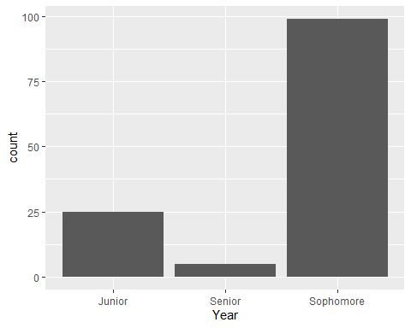

# Create a horizontal bar chart for Program of Study.  
ggplot(Data, aes(x=Program_of_Study))+geom_bar()+coord_flip()

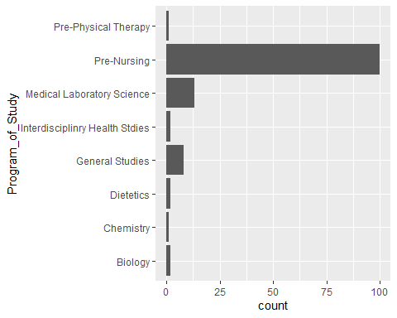

# **Task-3: Change color of all bars**

# All bars with same color  
ggplot(Data, aes(x=Year))+geom_bar(fill = "blueviolet")

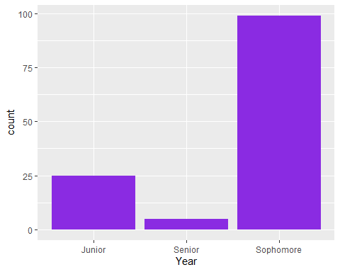

ggplot(Data, aes(x=Program_of_Study))+geom_bar(fill = "darkcyan")+coord_flip()

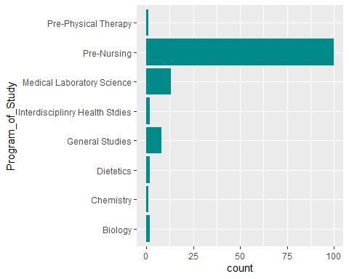

# each bar has different color   
ggplot(Data, aes(x=Year, fill=Year))+geom_bar()

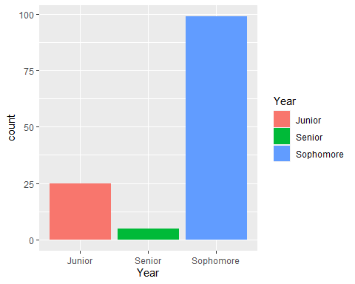

# **Task-4: Change the outline color of the bars so each is different according to the x-axis variable, leaving the fill white. You can use default colors, or the color brewer or grey scales**

# fill white and outline color  
ggplot(Data, aes(x=Year))+geom_bar(fill="white", color = "red")

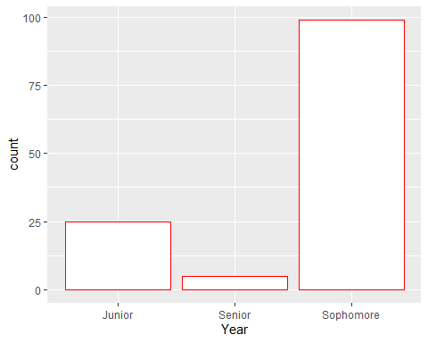

ggplot(Data, aes(x=Program_of_Study))+geom_bar(fill="white", color = "chocolate")+coord_flip()

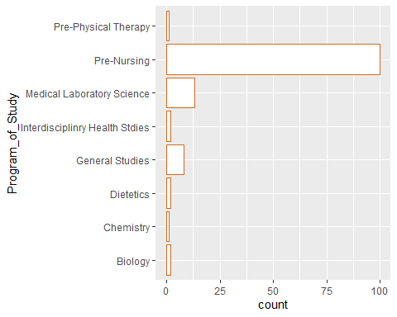

# Use of color brewer   
ggplot(Data, aes(x=Year,fill = Year,color = "red"))+geom_bar()+ scale_fill_brewer(palette = "YlOrRd")

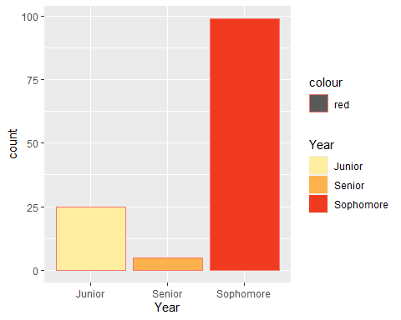

ggplot(Data, aes(x=Program_of_Study, fill = Program_of_Study, color="red"))+geom_bar()+coord_flip()+ scale_fill_brewer(palette = "Spectral")

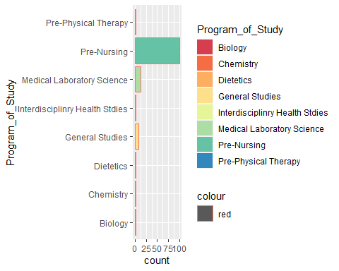

# Use of grey scales  
ggplot(Data, aes(x=Year,fill = Year, color = "red"))+geom_bar()+ scale_fill_grey(start=0.10, end = 0.90)+ theme_classic()

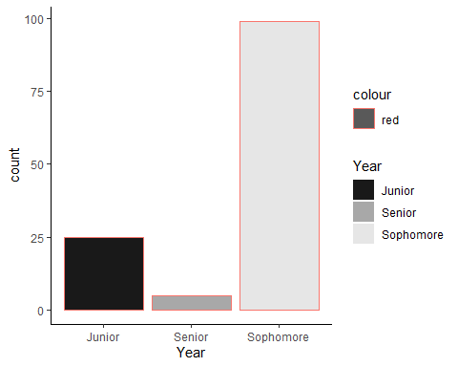

ggplot(Data, aes(x=Program_of_Study, fill = Program_of_Study, color = "red"))+geom_bar()+coord_flip()+ scale_fill_grey(start=0.10, end = 0.90)+theme_classic()

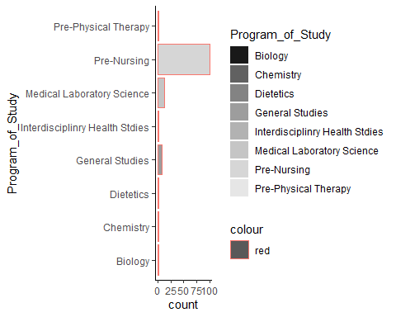

# **Task-5: Change the fill color of the bars so each is different according to x-axis variable**

ggplot(Data, aes(x=Year, fill=Year, color="red"))+geom_bar()

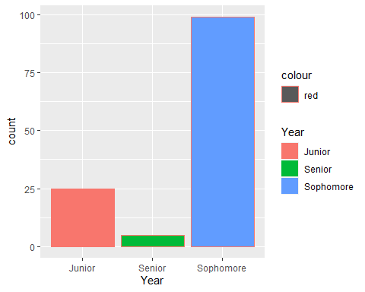

ggplot(Data, aes(x=Program_of_Study,fill=Program_of_Study, color = "chocolate"))+geom_bar()+coord_flip()

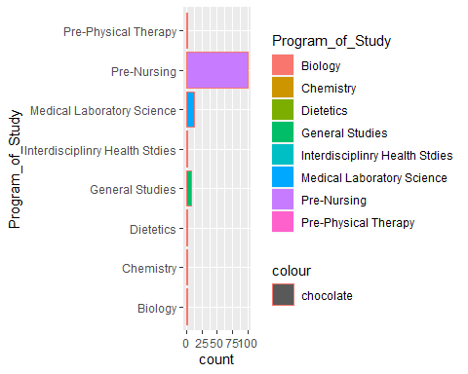

# **Task-6: Adjust bar width and theme**

# adjust bar width  
ggplot(Data, aes(x=Year, fill=Year, color="red"))+geom_bar(width = 0.7)

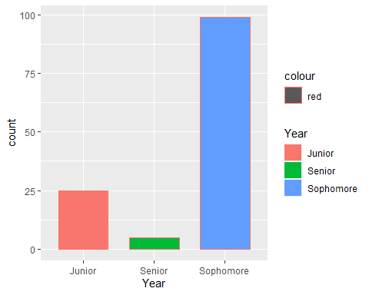

ggplot(Data, aes(x=Program_of_Study,fill=Program_of_Study, color = "chocolate"))+geom_bar(width = 0.6)+coord_flip()

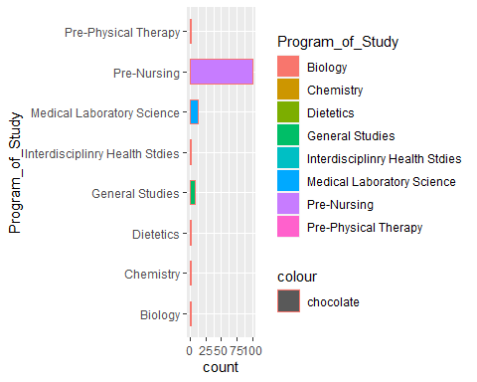

# adjust theme  
ggplot(Data, aes(x=Year, fill=Year, color="red"))+geom_bar(width = 0.7)+ theme_classic()

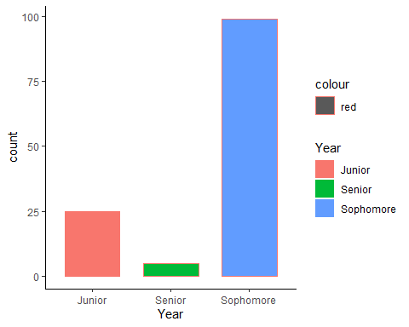

ggplot(Data, aes(x=Program_of_Study,fill=Program_of_Study, color = "chocolate"))+geom_bar(width = 0.6)+coord_flip()+ theme_classic()

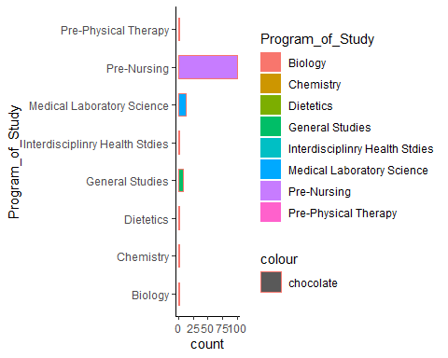

# **Task-7: Create a horizontal barplot in which categorical x-axis = Program of Study and continuous y-axis = Tophat_Qs_Correct. Then create vertical barplot in which categorical x-axis = Year and continuous y-axis = Tophat_total_Qs_answered.**

# Unsummarized data (seems wrong information in y-axis!!)  
# Create a horizontal barplot in which categorical x-axis = Program of Study and continuous y-axis = Tophat_Qs_Correct.  
ggplot(Data, aes(x=Program_of_Study, y=Tophat_Qs_Correct)) + geom_bar(stat="identity")

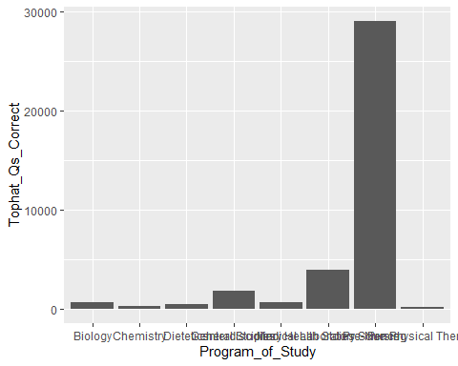

# I prefer to draw vertical barplot for this setup  
ggplot(Data, aes(x=Program_of_Study, y=Tophat_Qs_Correct)) + geom_bar(stat="identity") + coord_flip()

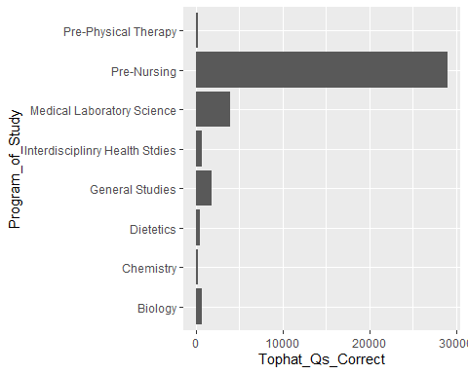

# Then create vertical barplot in which categorical x-axis = Year and continuous y-axis = Tophat_total_Qs_answered.  
ggplot(Data, aes(x=Year, y=Tophat_total_Qs_answered)) + geom_bar(stat="identity") + coord_flip()

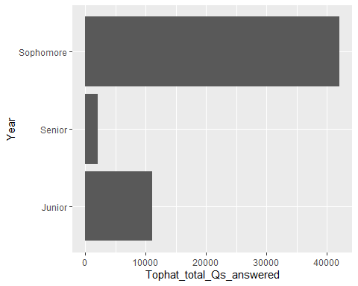

# I prefer to draw horizontal barplot for this setup  
ggplot(Data, aes(x=Year, y=Tophat_total_Qs_answered)) + geom_bar(stat="identity")

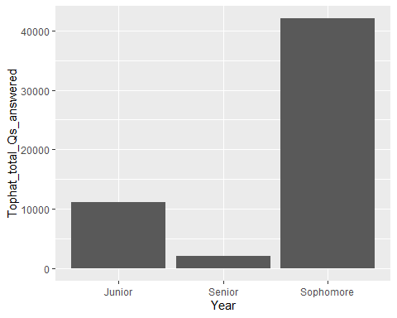

# **Task-8: Create a new object that contains presummarized data for the variables in the bar charts. Change the color of the bars.**

# categorical x-axis = Program of Study and continuous y-axis = Tophat_Qs_Correct  
means_CorrectPOS <- aggregate(Tophat_Qs_Correct ~ Program_of_Study, Data, FUN = mean)  
view(means_CorrectPOS)  
# Draw bar plot and change the colors of bars  
ggplot(data=means_CorrectPOS, aes(x=Program_of_Study, y=Tophat_Qs_Correct, fill=Program_of_Study)) + geom_bar(stat="identity") + coord_flip()+scale_fill_brewer(palette = "Spectral")

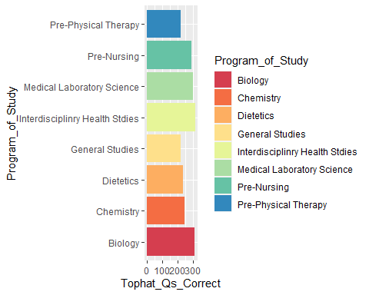

# categorical x-axis = Year and continuous y-axis = Tophat_total_Qs_answered.  
means_AnsweredYear <- aggregate(Tophat_total_Qs_answered ~ Year, Data, FUN = mean)  
view(means_AnsweredYear)  
# Draw bar plot and change the colors of bars  
ggplot(data=means_AnsweredYear, aes(x=Year, y=Tophat_total_Qs_answered, fill=Year)) + geom_bar(stat="identity", width = 0.6)

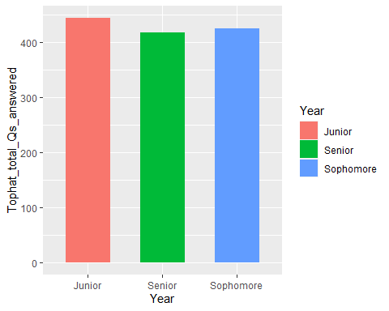

# **Task-9: Reorder the bars based on height**

# categorical x-axis = Program of Study and continuous y-axis = Tophat_Qs_Correct  
ggplot(data=means_CorrectPOS, aes(x=reorder(Program_of_Study,-Tophat_Qs_Correct), y=Tophat_Qs_Correct, fill=Program_of_Study)) + geom_bar(stat="identity") + coord_flip()+scale_fill_brewer(palette = "Spectral")

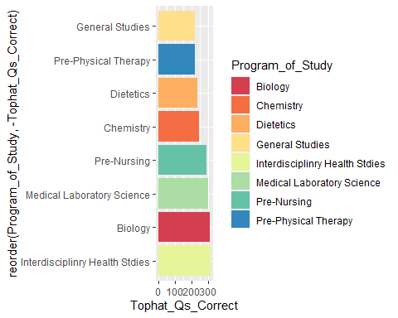

# categorical x-axis = Year and continuous y-axis = Tophat_total_Qs_answered.  
ggplot(data=means_AnsweredYear, aes(x=reorder(Year,Tophat_total_Qs_answered), y=Tophat_total_Qs_answered, fill=Year)) + geom_bar(stat="identity", width = 0.6)

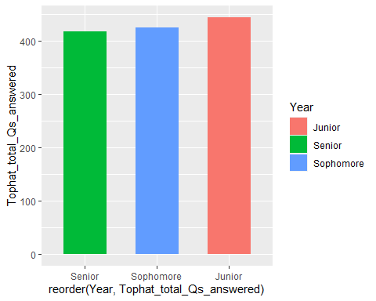

# **Task-10: Choose one of the plots above and create one variant of the bar chart: grouped barplot, dotplot, or lolliplot**

# Chosen barchart  
ggplot(data=means_CorrectPOS, aes(x=reorder(Program_of_Study,-Tophat_Qs_Correct), y=Tophat_Qs_Correct, fill=Program_of_Study)) + geom_bar(stat="identity") + coord_flip()+scale_fill_brewer(palette = "Spectral")



# dotplot  
ggplot(data=means_CorrectPOS, aes(x=Program_of_Study, y=Tophat_Qs_Correct)) + geom_point(size=4, color="red")+ theme_classic()+coord_flip()

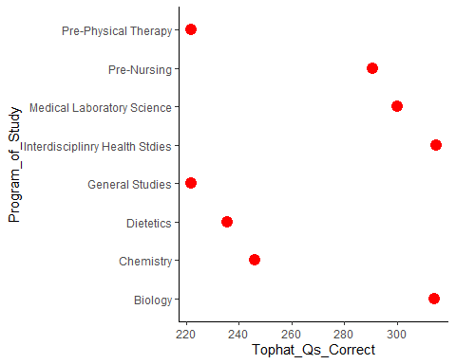

# lolliplot  
ggplot(data=means_CorrectPOS, aes(x=Program_of_Study, y=Tophat_Qs_Correct)) + geom_point(size=5, color="chocolate")+ geom_segment(aes(x = Program_of_Study, xend=Program_of_Study,y =0,yend=Tophat_Qs_Correct)) + theme_classic()+coord_flip()

